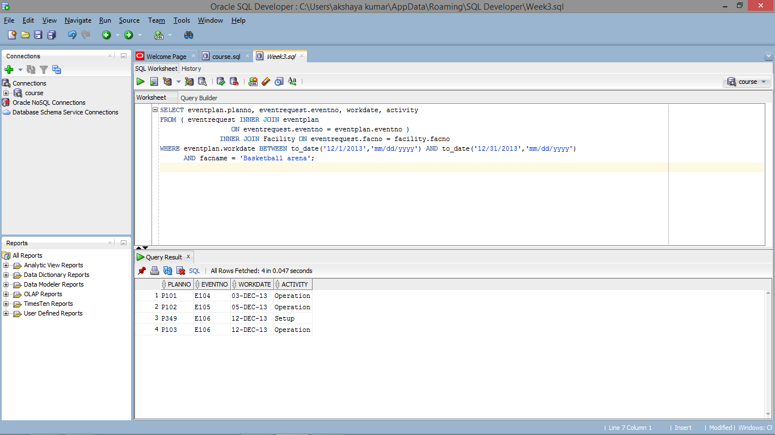

SELECT eventplan.planno, eventrequest.eventno, workdate, activity

FROM ( eventrequest INNER JOIN eventplan

ON eventrequest.eventno = eventplan.eventno )

INNER JOIN Facility ON eventrequest.facno = facility.facno

WHERE eventplan.workdate BETWEEN to_date('12/1/2013','mm/dd/yyyy') AND to_date('12/31/2013','mm/dd/yyyy')

AND facname = 'Basketball arena';